Capstone Project Group 2

Skill Assessment Software for special needs students

|  |
| --- |
| Lorenzo Bair |
| David Brooks |
| Harsajan Gill |
| Joseph Lin |
| Brian Brenner |

**Context Diagram for testing system showing top-level context:**

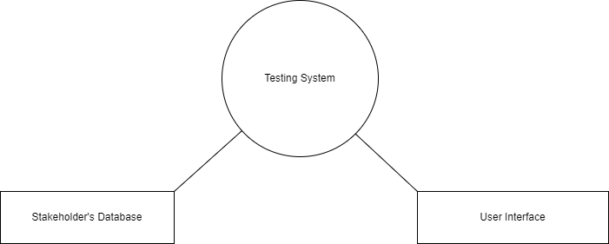

A student begins using the system in order to take an occupational placement assessment. The questions in this assessment are stored within the stakeholder’s database where they have compiled information pertaining to the questions and the skills that would or wouldn’t be associated with them depending on their responses. Our testing system then takes the user responses and ties them to their associated careers that our system has determined would be the best fit for the participant. During all of this, our system is preparing the necessary data to conveniently display all of this information into a user interface

**Base use case and data flow:**

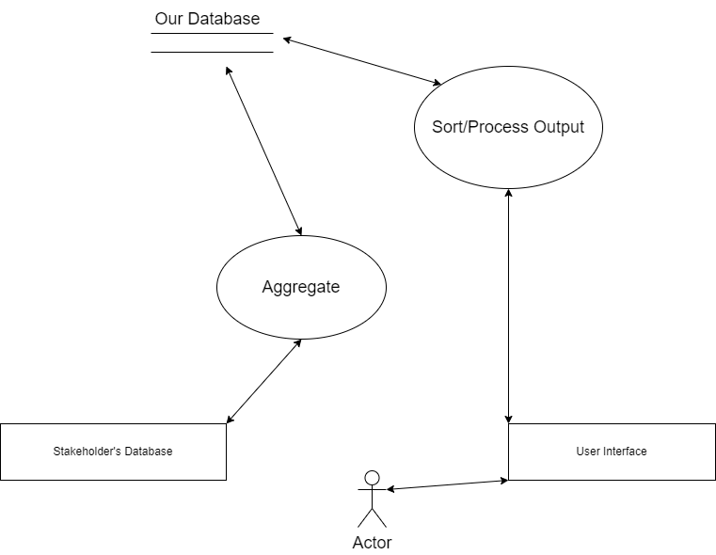

A student begins using the system in order to take an occupational placement assessment. The user interacts with our system through a user interface, which then communicates with a process to sort/process the desired output based on user input and the data we retrieve from our database. Our database has context from the stakeholder’s database that we aggregated and organized. This is our one and only use case as of now.

**Message Trace Exchange Diagram:**

When the end user visits the website (Employment Testing Software), it will ask them for their name. This will be used to print/send the report at the end of the assessment. After the user responds with their name, E.T.S. Processes it and enters the evaluation phase. The user will fill out the questions and then will submit the results back to the software. The software will then process the results and obtain top match job information. It will then be sent back to the user for final viewing and printing/saving.

**Current timeline:**

* February: Collect data and devise an algorithm to process data. Research database options.

**Deliverables**: Full data set to be tested against and a working database.

**Roles**:

Team: collecting data, database research/implementation.

* March: Start building back-end processes for handling the data. Build a simple front-end.

**Roles**:

Brian: Front End / Back End dev

Sarge: Front End Dev

David: DevOps/DB management

Lorenzo: Back End Dev

Joe: Back End

**Deliverables**: Functional backend that can perform requests and accurately deliver a payload.

* April: Refine our implementation and processes. Implement the final UI.

**Deliverables**: Efficient and streamlined data processing with accurate sorted lists of results.f

**Roles**: Brian, Lorenzo, and David: UI designers/developers.

Harsajan and Joe: Review previous code in order to refine our back-end implementations.